**Documentation of Lambda function**

**Flow of  testplus.dev which is used for test papers written in Go language.**

**(API is throwing some error)**

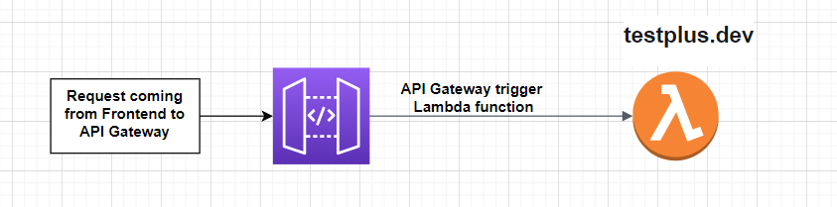

**Flow of yt-notes.txt for youtube notes written in Go language**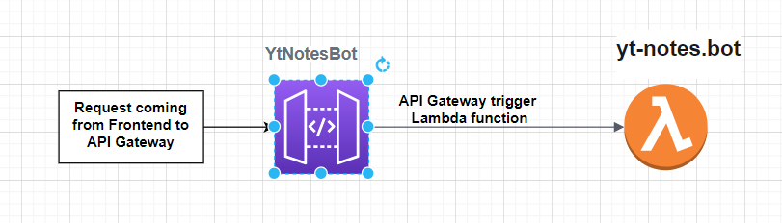

**Flow of IAS Paper for notification and paper procedure written in Go language**

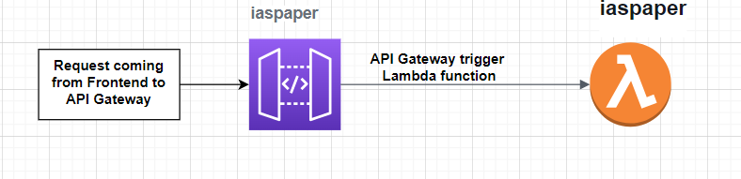

npm ERR! Conflicting peer dependency: mongodb@3.7.3

npm ERR! node_modules/mongodb

npm ERR! peerOptional mongodb@"^3.6.0" from typeorm@0.2.45

npm ERR! node_modules/typeorm

npm ERR! typeorm@"^0.2.45" from the root project

Flow of testplus-question-dev for   
  
